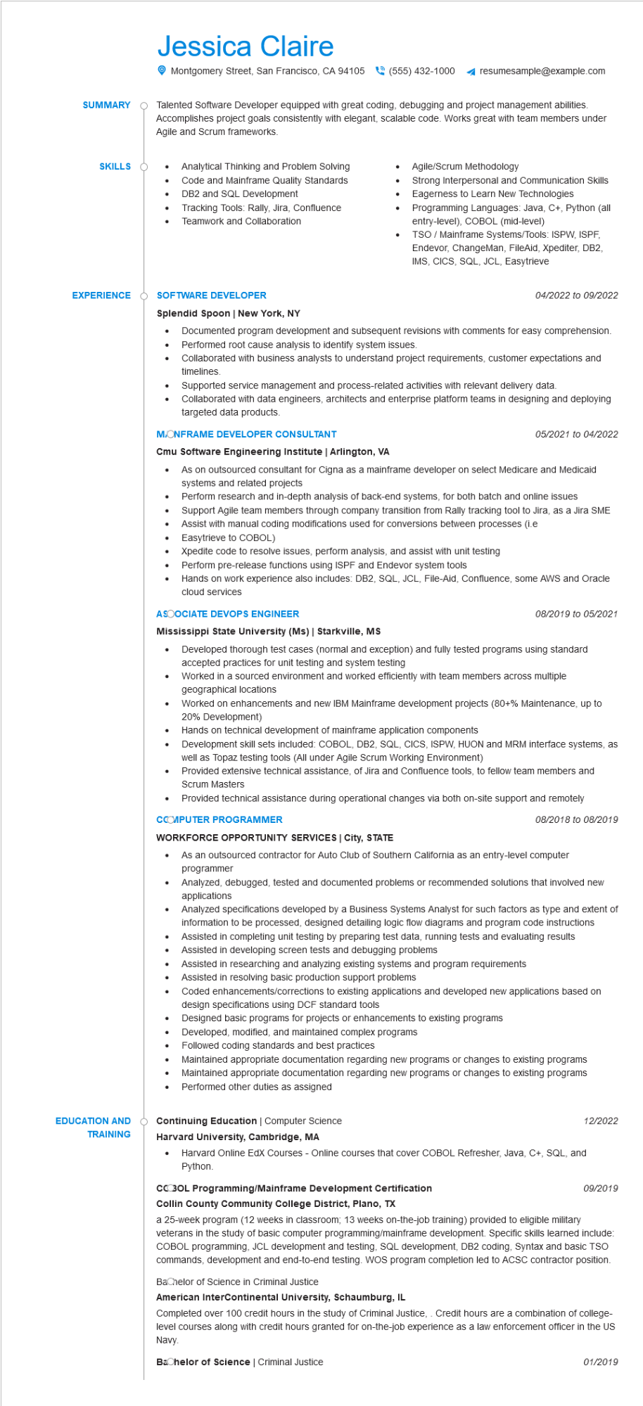
SUMMARY
SKILLS
EXPERIENCE
Jessica Claire
Montgomery Street, San Francisco, CA 94105 (555) 432-1000
resumesample@example.com
Talented Software Developer equipped with great coding, debugging and project management abilities. Accomplishes project goals consistently with elegant, scalable code. Works great with team members under Agile and Scrum frameworks.
•
•
Analytical Thinking and Problem Solving Code and Mainframe Quality Standards DB2 and SQL Development
Tracking Tools: Rally, Jira, Confluence
• Teamwork and Collaboration
•
Agile/Scrum Methodology
Strong Interpersonal and Communication Skills Eagerness to Learn New Technologies Programming Languages: Java, C+, Python (all entry-level), COBOL (mid-level)
TSO / Mainframe Systems/Tools: ISPW, ISPF, Endevor, ChangeMan, FileAid, Xpediter, DB2, IMS, CICS, SQL, JCL, Easytrieve
SOFTWARE DEVELOPER
Splendid Spoon | New York, NY
04/2022 to 09/2022
Documented program development and subsequent revisions with comments for easy comprehension. • Performed root cause analysis to identify system issues.
•
Collaborated with business analysts to understand project requirements, customer expectations and timelines.
Supported service management and process-related activities with relevant delivery data. Collaborated with data engineers, architects and enterprise platform teams in designing and deploying targeted data products.
M.ONFRAME DEVELOPER CONSULTANT
Cmu Software Engineering Institute | Arlington, VA
•
•
05/2021 to 04/2022
As on outsourced consultant for Cigna as a mainframe developer on select Medicare and Medicaid systems and related projects
Perform research and in-depth analysis of back-end systems, for both batch and online issues
Support Agile team members through company transition from Rally tracking tool to Jira, as a Jira SME
Assist with manual coding modifications used for conversions between processes (i.e
Easytrieve to COBOL)
Xpedite code to resolve issues, perform analysis, and assist with unit testing
Perform pre-release functions using ISPF and Endevor system tools
Hands on work experience also includes: DB2, SQL, JCL, File-Aid, Confluence, some AWS and Oracle cloud services
ASOOCIATE DEVOPS ENGINEER
Mississippi State University (Ms) | Starkville, MS
•
•
08/2019 to 05/2021
Developed thorough test cases (normal and exception) and fully tested programs using standard accepted practices for unit testing and system testing
Worked in a sourced environment and worked efficiently with team members across multiple geographical locations
Worked on enhancements and new IBM Mainframe development projects (80+% Maintenance, up to 20% Development)
· Hands on technical development of mainframe application components
•
Development skill sets included: COBOL, DB2, SQL, CICS, ISPW, HUON and MRM interface systems, as well as Topaz testing tools (All under Agile Scrum Working Environment)
Provided extensive technical assistance, of Jira and Confluence tools, to fellow team members and Scrum Masters
• Provided technical assistance during operational changes via both on-site support and remotely
CCOMPUTER PROGRAMMER
WORKFORCE OPPORTUNITY SERVICES | City, STATE
08/2018 to 08/2019
As an outsourced contractor for Auto Club of Southern California as an entry-level computer programmer
EDUCATION AND
TRAINING
•
Analyzed, debugged, tested and documented problems or recommended solutions that involved new applications
.
Analyzed specifications developed by a Business Systems Analyst for such factors as type and extent of information to be processed, designed detailing logic flow diagrams and program code instructions Assisted in completing unit testing by preparing test data, running tests and evaluating results Assisted in developing screen tests and debugging problems
.....
Assisted in researching and analyzing existing systems and program requirements
Assisted in resolving basic production support problems
Coded enhancements/corrections to existing applications and developed new applications based on design specifications using DCF standard tools
Designed basic programs for projects or enhancements to existing programs
•
Developed, modified, and maintained complex programs
•
Followed coding standards and best practices
•
•
•
Maintained appropriate documentation regarding new programs or changes to existing programs Maintained appropriate documentation regarding new programs or changes to existing programs Performed other duties as assigned
Continuing Education | Computer Science
Harvard University, Cambridge, MA
12/2022
• Harvard Online EdX Courses - Online courses that cover COBOL Refresher, Java, C+, SQL, and Python.
CCOBOL Programming/Mainframe Development Certification Collin County Community College District, Plano, TX
09/2019
a 25-week program (12 weeks in classroom; 13 weeks on-the-job training) provided to eligible military veterans in the study of basic computer programming/mainframe development. Specific skills learned include: COBOL programming, JCL development and testing, SQL development, DB2 coding, Syntax and basic TSO commands, development and end-to-end testing. WOS program completion led to ACSC contractor position.
Bachelor of Science in Criminal Justice
American InterContinental University, Schaumburg, IL
Completed over 100 credit hours in the study of Criminal Justice,. Credit hours are a combination of college- level courses along with credit hours granted for on-the-job experience as a law enforcement officer in the US Navy.
Bachelor of Science | Criminal Justice
01/2019

